

Issue 125 February 2008

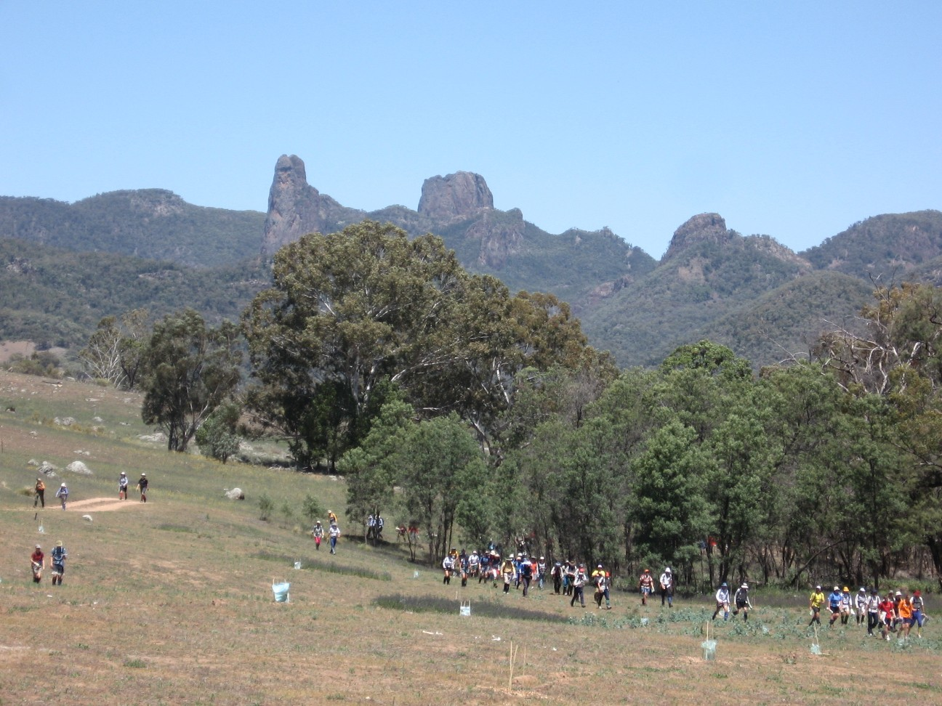
It all seems so long ago – the 2006 World Rogaining Championships at Coonabarabran – but, we are bringing you the 2008 Australian Championships
www.nswrogaining.org

2008 ROGAINING CALENDAR
Date | Event | Location | Contact
24 February 2008 | Metrogaine | Nth Syd Beaches | www.nswrogaining.org
19/20 April 2008 | NSW Champs | South Coast | www.nswrogaining.org
15 June 2008 | Paddy Pallin | West of Sydney | www.nswrogaining.org
ACT Events
6 April 2008 | Paddy Pallin 6 hr | ACT | act.rogaine.asn.au
17-18 May 2008 | State Championship | ACT | act.rogaine.asn.au
29 June 2008 | Cycle and Foot | ACT | act.rogaine.asn.au
Other Events
16-17 Aug 2008 | Australian Champs | NSW | www.nswrogaining.org


THE 2007 NSWRA COMMITTEE

Please note – the AGM will be held after the Metrogaine and nominations are sought for all positions.

President - Mike Hotchkis
Email: m_d.hotchkis@optusnet.com.au 02 4294 1363 (h)

Vice President – This position is currently vacant and seeking a volunteer

Secretary – Alexa McAuley
Email: nswrasecretary@gmail.com 02 9460 3514 (h)

Public Officer – Julian Ledger
Email: julianledger@optusnet.com.au 02 9416 6423 (w)

Treasurer – Tony Maloney
Email: anthony_maloney@promina.com.au 02 9636 5830

Event Manager - Paul Stein
Email: steins@bigpond.net.au 02 4630 9545 (h)

Membership Secretary – Ian Almond
Email: ian.almond@tpg.com.au 02 4271 7465 (h)

Newsletter Editor – Peter Cox
Email: pacox@hunterlink.net.au 02 4981 7505 (h)

Webmaster – Graeme Cooper
Email: graeme_cooper@northnet.com.au 02 6772 3584

Publicity Co-ordinator – Ineke Kuiper
Email: ine_kuiper@hotmail.com 0408 669 638

Safety Officers – Richard Sage / Alan Mansfield
Email: danis-sage@bigpond.com , nswrogaining@optusnet.com.au

ARA Representative – Alan Mansfield
Email: nswrogaining@optusnet.com.au 02 9797 6773

Volunteer Co-ordinator – Graeme Cooper
Email: graeme_cooper@northnet.com.au 02 6772 3584

Equipment Officer – Bert van Netten
Email: bert.vannetten@bigpond.com 02 4975 3693

General Committee – David Sigley
Email: davidsigley2004@yahoo.com.au 02 9687 0301

2008 ANNUAL GENERAL MEETING

Notice of meeting and call for nominations for Committee positions

The 2008 AGM of the New South Wales Rogaining Association Incorporated will be held at approximately 4.00pm on Sunday 24th February at the Hash House after the Metrogaine on that day).

Agenda

- Adoption of the Minutes of the 2007 AGM
- President’s report – Mike Hotchkis
- Treasurer’s report – Tony Maloney
- Adoption of the reports including the 2007 financial statements
- Proposed motion to modify the NSW Rogaining Association’s Rules (*the NSWRA constitution)
- Election of Office Bearers / Committee members
- General business

All committee positions are up for election and nominations are now open – for details of each role and nomination forms, see under ‘About NSWRA’ on our website (www.nswrogaining.org). Nominations should preferably be sent to the Secretary prior to the AGM.

New blood is very welcome, so if you have some ideas, would like to make a contribution to the running of the Association, or would just like to know how it works, please contact current president Mike Hotchkis or any other committee member. Some of your time and enthusiasm will help make for even better rogaining in NSW in 2008.

Note: * Details of this motion, to be proposed by the current President, will be posted on our website and made available at the AGM. The motion will not be proposed unless endorsed by the committee in advance of the meeting.

NSWRA CELEBRATES ITS 25TH ANNIVERSARY

Although a rogaining association was first formed in NSW in 1983, NSW had a history of successful organisation of 24 hour walks (much like present day rogaining) during the 1970s and early 1980s. In addition, Paddy Pallin organised an annual three and a half hour score orienteering event using topographic maps close to the Sydney area. However, these events were organised infrequently and getting your rogaining fix on a regular basis required travelling to Victoria.

By late 1982, a critical mass of expertise had developed in NSW sufficient to establish rogaining on a sounder footing. Jeremy Challacombe, an experienced Victorian rogainer had moved to Armidale, the Northern Tablelands Orienteering Club was organising an annual six hour event, Bert and Dianne Van Netten and I had competed in a number of Victorian rogaines, and Peter and Robyn Tuft had organised several 24 hour walks in NSW.

Bert, Jeremy and I chose a point roughly equidistant between Newcastle and Armidale to organise a 24 hour rogaine on May 21/22, 1983 and called the event the NSW Rogaining Championships. The entry fee was $12. We relied on publicity through orienteering and bushwalking clubs to promote the event.
Staged just east of Murrurundi in the upper Hunter Valley, the event straddled the Liverpool Range and comprised mostly open and semi-open farmland. We used the Temi, 1:25000 topographic map, and as was typical of the time, all competitors received a copy of the topographic map and a list of checkpoints with six figure grid references with which they plotted the location of the checkpoints on their map.
There had been heavy rain in the lead up and we were concerned about getting competitors into and out of the event. The rain continued off and on throughout the event so the Hash House (the shearing shed on Swegn Smith’s property, with its attendant smell) was well used by competitors.

Sadly, my records are incomplete and don’t include the results for the Murrurundi event. However, I mailed a note to all competitors in June 1983 advising them that they were financial members of the NSW Rogaining Association and advised them of a meeting in Sydney in the following month to formalise this arrangement and to ratify a constitution. There were 80 members of NSWRA in November 1983.
The Victorian Rogaining Association kindly agreed to add our members to their newsletter mailing list until we began producing regular newsletters in 1984.

A second NSWRA rogaine, a 12 hour event, was run at Armidale in November 1983. By the end of that year it was clear that rogaining was likely to develop strongly in this state. An indication of this was that Peter and Robyn Tuft successfully organised the 1984 Australian Rogaining Championships for NSWRA.

Ian Dempsey

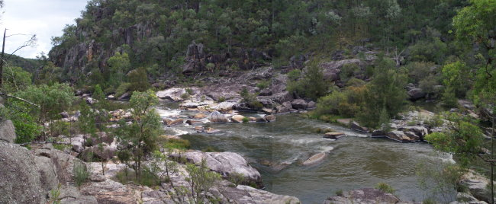
A scene from the 2008 Australian Rogaining Championship, will you be there?

VOLUNTEERS ARE NEEDED

Everyone who has ever done a rogaine will understand that there is a need for volunteers at every event. Assistance is needed with the planning and organising, with the setting and vetting of the course, with the placement and retrieval of checkpoints before and after the event. Volunteers also help in the kitchen for the well earned food after an event, and many other thankless tasks.
The committee asks that everyone who competes in our sport offers to be a volunteer at one event each year. Ultimately, no volunteers means no events.

PLEASE BE A VOLUNTEER AT AN EVENT EACH YEAR

Another view from the Gwydir River – home of the 2008 Australian Rogaining Championships
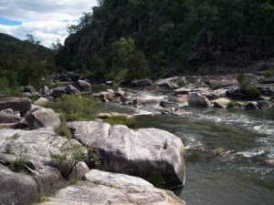

OUR NEXT EVENT

THE BRIDGE TO BEACH METROGAINE
24 FEBRUARY 2008

Here is your invitation to participate in the 2008 Metrogaine to be centred around Sydney’s northern beaches on Sunday, 24th February. The event will encompass some of the country’s finest and most spectacular beachside scenery, together with some bush tracks which discover creeks and waterfalls and a variety of rock formations.

You may enter the event in teams of two, three, four or five. There will be categories for male, female and mixed teams and age classes for juniors, open, veterans and super veterans. Navigation will be on the easier end of the scale.

Teams will set off on their chosen route from near the southern end of Pittwater. Heading west will encounter some steep hills and bushland tracks, and fitness and speed through these areas will be rewarded with some high value points. Or you might prefer to head north along the picturesque shores of Pittwater with its many parks and marinas. Other teams might head straight for the spectacular headlands and beaches where plenty of points will be on offer.
Turimetta Headland alone is worth a visit, and there are numerous seats and picnic tables in this area if you reach here about lunch time. Whichever route you decide to take, you will be offered breathtaking views of some of Sydney’s famous coastline.

As there will be numerous controls right on the beaches, why not bring along your swimming costume and go for a dip along the way? Or perhaps revisit your favourite spot after the event and organise a barbeque tea there with your friends. If you are feeling like a cuppa en route, there are several cafes and fast food outlets that will cater for your cravings. There are plenty of taps and bubblers along the foreshores, but it is advisable to also carry adequate supplies of water, especially if you are heading inland.

We also promise you that you will learn a bit about the history of the area and visit some of the earliest structures to be built here. The castle on the headland itself is a hidden treasure. Of course, there will be the usual hash house at the end of the vent to console your hunger and it will also provide you with a chance to discuss your route choices with other teams

We cannot guarantee what the weather will be like on the day, but there is every chance that it will be considerably cooler than the inland suburbs at this time of the year and it is most likely that there will be a sea breeze blowing. So form a team soon and get your entry in early!

Graeme Hill

Graham Hill and Anne Newman are the organisers and course setters for this rogaine
For general information about this event, contact Anne Newman, phone: 02 9982 4836
For entry or results related matters contact Paul Stein, phone: 02 4630 9545

There will be a lot of wet feet for 10 points at the Australian Rogaining Championships. Please make sure you stay within 5 metres of your team mate at the control point to avoid disqualification.

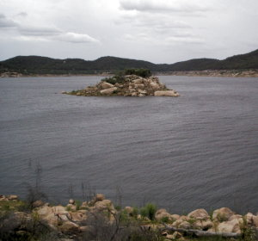

Volunteers for upcoming NSWRA Rogaines - To add your name to the list below, please contact the Volunteer Co-ordinator, Graeme Cooper, Ph: 6772 3584 or email graeme_cooper@northnet.com.au

Event | Organiser | Administrator  Assistants | Course Setter  Assistants | Vetter  Flag Retrieval | Hash House  Leader  Team | Site Staff | Photographer  Safety Officer
Metrogaine  6 hour  24 February 2008 | Anne Newman | Paul Stein  Ian Almond | Anne Newman  Graham Hill | Not needed!
NSW Championships  24 hour  19 - 20 April 2008 | Trevor Gollan |  | Phil Whitten | Stephen Thompson |  | Stephen Thompson
Paddy Pallin  6 hour  15 June 2008 |  |  | Nicole Sellin  Nigel McDonald
Aust Champs  24 hour  15 -16 August 2008 | Michael Watts | Andrew & Belinda Pope | Graeme Cooper | Michael Watts | Vicki Cooper
Lake Macquarie  6/12 hour  11 October 2008 |  | Bob Gilbert
Socialgaine  6 hour  16 November 2008 |  |  | Gill Fowler

Results of 2007 Socialgaine – Port Stephens – 18 November 2007
Team | Team Members | Score | Time | O | M | W | X | V | S | J | N | F
81 | Chris Graham, Richard Green, Joel Mackay | 1700 | 5:59 | 1 | 1
66 | Relene Fenrich, Jeremy Welbourne | 1690 | 5:55 | 2 |  |  | 1
23 | Matt Dowle, Gill Fowler | 1600 | 5:50 | 3 |  |  | 2
25 | Brendan Hatton, Warwick Selby | 1540 | 5:54 | 4 | 2
22 | Malcolm Bradley, Keith Mearns | 1490 | 6:18 | 5 | 3
10 | Stu Adams, Jamie van Netten, Kim van Netten | 1480 | 5:54 | 6 |  |  | 3
65 | Matt De Belin, Matt Shields | 1480 | 5:56 | 7 | 4
76 | Richard Lauder, Jacqui Matthews | 1440 | 5:46 | 8 |  |  | 4
59 | Peter Glen, Damian Welbourne | 1400 | 6:09 | 9 | 5
30 | Shelley Bambrook, Christine Quigley | 1380 | 5:55 | 10 |  | 1
8 | Bill Chalmers, Caroline Chalmers | 1330 | 5:56 | 11 |  |  | 5 | 1 | 1
67 | Thomas Griffith, Miles Waring | 1300 | 5:54 | 12 | 6 |  |  |  |  | 1
71 | Geoff Peel, Margaret Peel | 1290 | 5:59 | 13 |  |  | 6
16 | Brendan Byrne, Edwina Hatch | 1210 | 5:50 | 14 |  |  | 7
89 | Anthony Lillycrop, Jane Lillycrop | 1210 | 5:58 | 15 |  |  | 8
32 | Alexa McAuley, John Zvonar | 1190 | 5:52 | 16 |  |  | 9
7 | Heiko Schaefer, Mark Schaefer | 1190 | 6:04 | 17 | 7
20 | Wendy Scott, Trish Guy, Steve Guy | 1160 | 5:51 | 18 |  |  | 10 | 2
45 | Richard Robinson, Wendy Stevenson | 1140 | 5:46 | 19 |  |  | 11 | 3
62 | Thomas Schipilliti, Andrew Stanford, Adrian Watson | 1110 | 5:58 | 20 | 8
44 | David Longman, Gordon Millward | 1110 | 6:16 | 21 | 9
68 | David Griffith, Mike Hotchkis | 1100 | 5:57 | 22 | 10 |  |  | 4
12 | Craig Kentish, Brian McKevitt | 1070 | 5:55 | 23 | 11
49 | Adam Halstead, Kirsty Young | 1050 | 5:50 | 24 |  |  | 12
2 | Neil Chappell, David Lilley | 1050 | 5:53 | 25 | 12 |  |  | 5 | 2
24 | Anthony Hayes, Louise Hayes | 1020 | 5:52 | 26 |  |  | 13 | 6
31 | Tom Brennan, Rachel Grindlay | 1010 | 5:52 | 27 |  |  | 14
26 | David Hegarty, Chris Jacka | 1000 | 5:28 | 28 | 13
52 | David Bowerman, Ernest Windschuttel | 1000 | 5:56 | 29 | 14 |  |  | 7 | 3
79 | Mark Anderson, Elissa Erickson | 1000 | 5:58 | 30 |  |  | 15 |  |  |  | 1
90 | Nicholas Arney, Sally Russell, | 990 | 5:49 | 31 |  |  | 16
19 | Chippy Le Carpentier, Eric Smith | 990 | 6:05 | 32 | 15 |  |  | 8 | 4
Team | Team Members | Score | Time | O | M | W | X | V | S | J | N | F
37 | Anne-Maree Carruthers, Paul Carruthers | 980 | 5:59 | 33 |  |  | 17
11 | John Barnes, Mardi Barnes | 960 | 5:53 | 34 |  |  | 18
48 | Meigan Geileskey, Mark Russell, Shawn Russell, Shane Weeks | 940 | 5:53 | 35 |  |  | 19 |  |  |  | 2
4 | Nigel McDonald, Nicole Sellin | 930 | 5:42 | 36
21 | Sarah Bacon, Greg Bacon, Kerry Bacon, Matt Bacon, Sarah Hartwig | 930 | 6:39 | 37 |  |  | 20
77 | Rosalie Ashe, Anthony Dowle | 900 | 5:53 | 38 |  |  | 21 |  |  |  | 3
46 | Simon Blake, Rob Higley, Daniel Keating | 900 | 5:57 | 39 | 16
9 | Sue Clark, Nihal Danis, Richard Sage | 850 | 5:36 | 40 |  |  | 22 | 9
86 | Doug Floyd, Beth Symonds | 800 | 5:43 | 41 |  |  | 23 | 10
51 | Michael Minehan, Jim Phimister | 800 | 5:51 | 42 | 17 |  |  | 11 | 5
78 | Grant Campbell, Simon Edds | 800 | 5:55 | 43 | 18
80 | Karen Canfell, Pauline Evans, Susan Login | 790 | 5:45 | 44 |  | 2
5 | Lynn Dabbs, Kevin Williams | 780 | 5:41 | 45 |  |  | 24 | 12 | 6
57 | Louise Dearnley, Martin Dearnley | 760 | 5:49 | 46 |  |  | 25 |  |  |  |  | =1
63 | Karen Jameyson, Tristan White | 760 | 5:49 | 47 |  |  | 26 |  |  |  |  | =1
60 | Debbie Byers, Andrew Lumsden | 740 | 5:40 | 48 |  |  | 27 | 13
58 | Richard Milnes, David Perkins, Gillian Perkins, Michael Thompson, Margaret Weiss | 710 | 5:54 | 49 |  |  | 28
64 | Anne Spragge, Adam Carr, Belinda Carr, Ben Spragge | 710 | 5:55 | 50 |  |  | 29 |  |  |  | 4
56 | Marty Middlebrook, Alok Vyas | 680 | 6:17 | 51 | 19
74 | Erica Harmes, Daniel Harmes, Jeremy Steele | 670 | 5:51 | 52 |  |  | 30
43 | Fiona Merritt, Josh Merritt, Lauren Merritt, Tony Merritt | 670 | 5:57 | 53 |  |  | 31 |  |  |  |  | 3
1 | Alec Noble, Liz Noble | 660 | 5:26 | 54 |  |  | 32 |  |  |  |  | 4
14 | Pam Montgomery, Robert Montgomery | 660 | 5:38 | 55 |  |  | 33 | 14 | 7
38 | Chris Welbourne, Helen Welbourne | 630 | 5:31 | 56 |  |  | 34 | 15 | 8
34 | Katie Hardy, Chris Hardy | 620 | 6:10 | 57 |  |  | 35
3 | Chris Mottram, Meagan Mottram | 620 | 3:20 | 58 |  |  | 36
13 | Bruce O’Brien, Kelsey O’Brien | 580 | 5:58 | 59 |  |  | 37 |  |  |  |  | 5
42 | Hans Mistler, Susan Mistler | 570 | 5:51 | 60 |  |  | 38 | 16
69 | Renate Griffith, Debbie Hotchkis | 560 | 5:52 | 61 |  | 3 |  | 17
Team | Team Members | Score | Time | O | M | W | X | V | S | J | N | F
55 | Neerav Bhat, Vivek Chaurasia, Donna McKenzie, Shaleen Srivastava | 550 | 5:51 | 62 |  |  | 39
54 | Charles Bowden, Trish Gorring, Wayne Lee, Alison Lyon, Len Sharp | 530 | 5:46 | 63 |  |  | 40
50 | Ryan Hudson, Caronline Taurany | 530 | 5:48 | 64 |  |  | 41 |  |  |  | 5
88 | Tomoka Harada, Peter Washington | 460 | 5:40 | 65 |  |  | 42
47 | Lana Assaf, Deb Speed, Ray Regmi, Megan Williams, Matt Williams | 460 | 6:10 | 66 |  |  | 43 |  |  |  | 6
83 | Warren Pereira, Shomo Sen | 450 | 6:05 | 67 | 20 |  |  |  |  |  | 7
17 | James Hubbard, Robert McNairn | 440 | 5:58 | 68 | 21 |  |  | 18 | 9
18 | Lynne McNairn, Marty Robinson | 440 | 5:58 | 69 |  |  | 44 | 19
53 | Greg Tuckwell, Kym Tuckwell | 440 | 6:00 | 70 |  |  | 45 | 20
41 | Galia Nicolaev, Iavor Nicolaev, Iva Nicolaev, Nikolay Nocolaev | 420 | 5:38 | 71 |  |  | 46 |  |  |  |  | 6
84 | Wesley Stein, Daniel Stein, Judith Stein, Emily Stein, Hamish Stein | 410 | 5:40 | 72 |  |  | 47 |  |  |  | 8 | 7
75 | Graham Christy, Nhu Doan, Renae Martin | 360 | 5:46 | 73 |  |  | 48
33 | Graeme Cooper, Vicki Cooper | 330 | 6:00 | 74 |  |  | 49 | 21 | 10
87 | Debbie Atchinson, Denise Clark, David Clark, Elise Jach | 330 | 6:29 | 75 |  |  | 50
35 | Pauleen Brinkworth, Timothy Lade | 280 | 6:14 | 76 |  |  | 51
6 | Elisa Allen, Yvonne Allen, David Dash, Willemine Dash | 270 | 3:53 | 77 |  |  | 52 |  |  |  |  | 8
40 | Andrew Pope, Belinda Pope, Nicholas Pope, Steven Pope, Shaun Pope | 260 | 5:15 | 78 |  |  | 53 |  |  |  | 9
28 | Dino Andreatta, Val Rose | 260 | 5:24 | 79 |  |  | 54 | 22 | 11
27 | Cassie Stein, Deb Stein, Jade Stein, Paul Stein | 240 | 5:23 | 80 |  |  | 55 |  |  |  | 10
36 | Rey Antonio, Irene Chan, Terry Lew | 0 | 6:29 | 81 |  |  | 56 |  |  |  |  | 9
73 | Gillian Mohring, Vicki Morrissey | Withdrwan
85 | Josh Blatchford, Steven Todkill | Withdrawn

