

Issue 122 July 2007

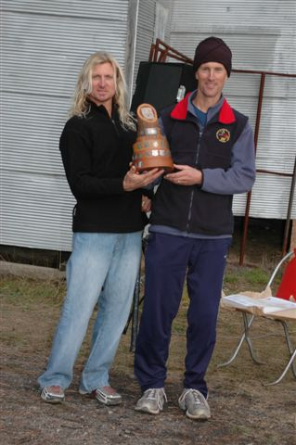

Winners of the 2007 Paddy Pallin Rogaine, Stu Adams and Rob Vincent

www.nswrogaining.org

2007 ROGAINING CALENDAR
Date | Event |  | Location |  | Contact
18 August 2007 | Lake Macquarie |  | Lake Macquarie |  | www.nswrogaining.org
20 October 2007 | NSW Championship |  |  |  | www.nswrogaining.org
18 November 2007 | Socialgaine |  | Port Stephens? |  | www.nswrogaining.org
ACT Events
5 August 2007 | Metrogaine |  | ACT |  | act.rogaine.asn.au
22 September 2007 | Nightgaine |  | ACT |  | act.rogaine.asn.au
3 November 2007 | Spring Rogaine |  | ACT |  | act.rogaine.asn.au
Other Events
28-29 July 2007 |  | Australian Champs |  | Alice Springs |  | http://nt.rogaine.asn.au


THE 2007 NSWRA COMMITTEE

President - Mike Hotchkis
Email: m_d.hotchkis@optusnet.com.au 02 4294 1363 (h)

Vice President – This position is currently vacant and seeking a volunteer

Secretary – Alexa McAuley
Email: nswrasecretary@gmail.com 02 9460 3514 (h)

Public Officer – Julian Ledger
Email: julianledger@optusnet.com.au 02 9416 6423 (w)

Treasurer – Tony Maloney
Email: anthony_maloney@promina.com.au 02 9636 5830

Event Manager - Paul Stein
Email: steins@bigpond.net.au 02 4630 9545 (h)

Membership Secretary – Ian Almond
Email: ian.almond@tpg.com.au 02 4271 7465 (h)

Newsletter Editor – Peter Cox
Email: pacox@hunterlink.net.au 02 4981 7505 (h)

Webmaster – Graeme Cooper
Email: graeme_cooper@northnet.com.au 02 6772 3584

Publicity Co-ordinator – Ineke Kuiper
Email: ine_kuiper@hotmail.com 0408 669 638

Safety Officers – Richard Sage / Alan Mansfield
Email: danis-sage@bigpond.com , nswrogaining@optusnet.com.au

ARA Representative – Alan Mansfield
Email: nswrogaining@optusnet.com.au 02 9797 6773

Volunteer Co-ordinator – Graeme Cooper
Email: graeme_cooper@northnet.com.au 02 6772 3584

Equipment Officer – Bert van Netten
Email: bert.vannetten@bigpond.com 02 4975 3693

General Committee – David Sigley
Email: davidsigley2004@yahoo.com.au 02 9687 0301

THIS IS YOUR NEWSLETTER ! ! ! ! !
I rely on members to provide me with its content, so please email me stories of the events you have competed in, photos from events or other things that will be of interest to rogainers (or even just of interest to you). If not, you are likely to be bombarded with stories and photos from the Cox family (BORING).
Peter Cox (Newsletter Editor)

President’s Piece
Paddy Pallin 6 hour
According to the weather bureau, we just had the wettest June for 30 years. Warragamba Dam is gradually filling up. So we should all be very happy with that. Just one small problem – Cox’s River cut our rogaine course in half! The wet weather had a few people thinking the event might have to be abandoned, but actually it wasn’t that bad over at Rydal on the west side of the Blue Mountains. But the river did rise to a level which would have made crossing it too hazardous.
The organisers made a good call on safety grounds, and closed that part of the course on the east side of the river. For most participants in this event, it did not make so much difference. Speaking for Debbie and I, we found plenty to keep us occupied on the west side of the river. It was nice rogaining country, with a little burbling creek in every gully. Just a few teams (15 in fact) ran out of checkpoints in 6 hours. But I’m sure they still enjoyed the chase.
The results came through promptly, thanks to the use of our new Navlight system.
I’d like to acknowledge a great effort from the organising team, especially Belinda and Andrew Pope and Ian Brown, and all their helpers. And also our hearts go out to those who spent hours setting and hanging flags on the east side of the river – the ones no-one got to visit! Perhaps we can have another rogaine there, just as soon as the river levels drop.
There are lots of pictures on our website and an entertaining article from one of the teams.
Australian Rogaining Championships, near Alice Springs …
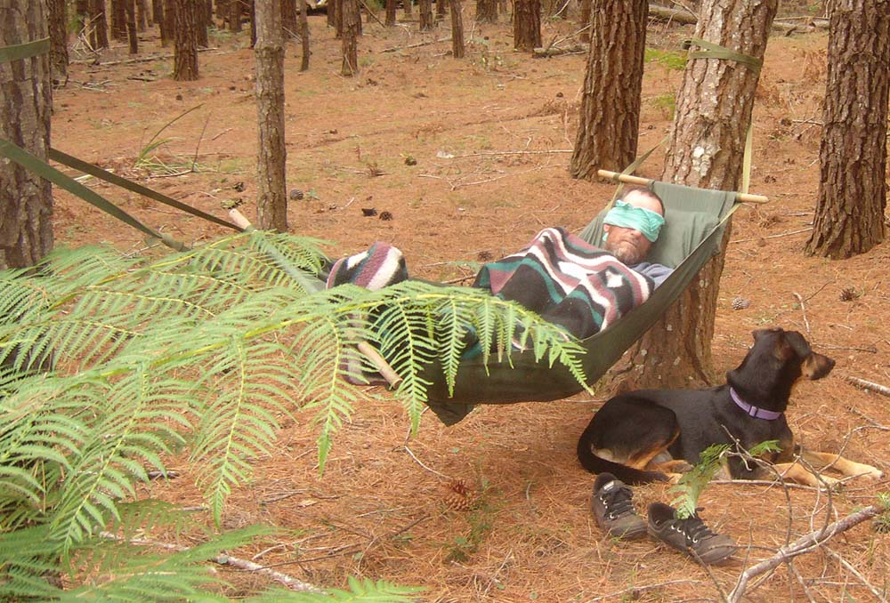
By the time this newsletter lands in your letterbox, it will be over for this year. I’m afraid I won’t be there myself but I am very happy to see plenty of NSW teams have entered the championships this year. The location must be the big attraction – the first time a rogaine has been held in the Red Centre. And the first time the Northern Territory Rogaining Association has organised the championships.
45 NSW attendees at last count. I look forward to hearing about your experiences. Please write something about it and / or send in your photos for inclusion in our newsletter and on our website.
Our president reflects on missing this years Australian Championship.

… and next year, closer to home
Next year’s Australian Championships will be in NSW. Graeme Cooper and others are already working on it. Contact Graeme if you’d like to get involved.
Lake Macquarie Rogaine
I’ve lost count but at a guess I think this could be the 15th year of the ever-popular Lake Macquarie rogaine. It’s next on our calendar and you’ll find details within.
Reminder
We encourage all members to sign up to our email list. This is an important way for rogainers to keep in touch and know what’s going on. Sign up and you can be sure you won’t miss the next event entry deadline. Visit our website to sign up: www.nswrogaining.org.

VOLUNTEERS ARE NEEDED

Everyone who has ever done a rogaine will understand that there is a need for volunteers at every event. Assistance is needed with the planning and organising, with the setting and vetting of the course, with the placement and retrieval of checkpoints before and after the event. Volunteeers also help in the kitchen for the well earned food after an event, and many other thankless tasks.
The committee asks that everyone who competes in our sport offers to be a volunteer at one event each year. Ultimately, no volunteers means no events.

PLEASE BE A VOLUNTEER AT AN EVENT THIS YEAR

OUR NEXT EVENT
2007 Lake Macquarie Rogaine
The Lake Macquarie Rogaine will once again be held on Saturday 18th August, in the Watagan Mountains as part of the Lake Macquarie Games and supported by the Lake Macquarie City Council
The Watagan Mountain is west of Australia’s largest coastal salt water lake and with the location for this years event being north of the area known as The Pines it is only two hours north of Sydney. The area to be used will mostly be in the Watagan National Park with beautiful rainforest, pristine creeks, friendly fauna and an extensive track network to allow competitors the option of avoiding some of the navigation through dense vegetation. There will be 12 and 6 hour events, both starting at 12 midday. An application will be included with this newsletter.
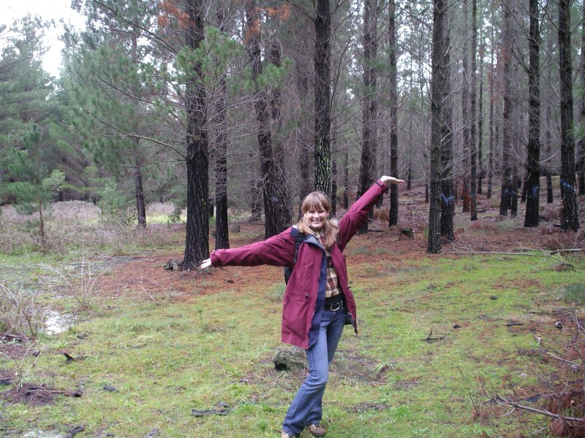

Michaela Kupcakova enjoys the Paddy Pallin Rogaine a bit too much.

The random mumblings of an event organiser.....
By Andrew (and Belinda) Pope

Somehow Bindi and I had ended up being roped into doing the organisation and administration for the 2007 Paddy Pallin Rogaine. Graeme Cooper had lined up Ian Brown to do the course setting.

On a perfect day in March we met up with Ian at the Rydal Showground. The choice of hash house site was excellent and the bush to the east I knew from previous experience made for good navigation. It seemed we were set. The small ankle deep river running through the middle of the course didn't look like it would be a problem. It would take drought-breaking rains to make it impossible to cross... hmmmm…..

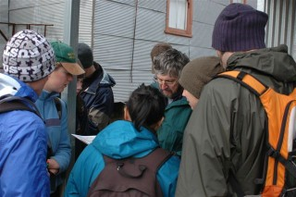
Early April brought the first calls from eager competitors wondering when they could enter prompting Belinda and Andrew Introna to put the brochure together for printing and mailing. This coincided with the opening of the online entries on the website. The entries soon came flooding in. Over 90% being received electronically making admin much easier. By closing day we reached the quota of 800 entrants and unfortunately had to turn a number of teams away. (So remember get your entries in early!)

Despite all of Ian’s efforts we couldn’t locate the landholder for the area immediately east of the hash house. An area that had in many parts been thoroughly torn up by trail bike riders. This meant that there was a narrow exit to the north to access the course. By the end of April Ian reported that the course was mostly set and vetted.

In early May I wandered up to vet the last six controls. My first impressions were that it was tough! I left the car and went down, then up, then down, crossed the river without getting my feet wet, went up, found the control on a beautiful knoll, turned around, went down, followed the river, crossed and then spent the next half hour losing blood to the blackberry bushes before finally getting back to the car. Only five more controls to go. The next four controls convinced me that I must get fitter! The last one (and the only one used on the day) was near the hash house in lovely open bush. :-)

then it started raining....

Flag hanging was originally planned for the Saturday of the long weekend. Some softer elements of the flag hanging team asked that it be moved to Sunday something about hypothermia (OK…OK it was blowing a gale very wet and cold)... and then finally moved to Monday. The team met at the showground early to go through flag /navlight hanging procedures. Ian had the steep southeast corner. Julian Ledger had the very steep north east corner.. Tony Garbellini and Geoff Luscombe had the pine forest and I had the nice easy area close to the hash house. I thoroughly enjoyed my circuit through the open bush with very little offensive trail bike activity. The water was a little higher now and one control placed over a previously dry creek now had half a metre under it! Not to worry the rain can’t continue. Arriving back at the entrance to the state forest I waited for the others to arrive. The peace was intermittently shattered by police cars screaming past chasing unregistered trail bikes.
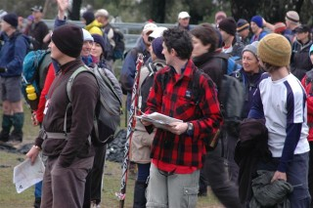
Ian turned up at about 4:00pm saying we had more controls to hang and he still had to track down Julian. As Ian drive along roads I’d probably walk my mountain bike down I decided that 4wd’ing as a passenger is more about abuse than enjoyment. Julian was found, my mobile phone was lost (and then found), and the final few controls were hung just on dark.

Friday before the event had me at the showground with the keys checking out the facilities. The weather was quite pleasant. I had a minor panic attack when I found that two of the toilet blocks were not quite what they seemed with only two dunnies between them. The other two blocks appeared to have some plumbing challenges... My mind filled with visions of being lynched for not providing enough dunnies. Thankfully the gents at Bathurst portables rescued me by delivering six loos that afternoon. Also resolved that admin would be nice and cosy (and dry) in the new hall with 1st Waitara taking the kitchen and adjacent hall. Positive Luxury!
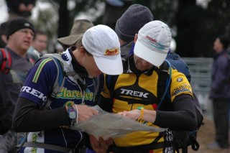
mmm lamb shanks (Friday night dinner)!

Early Saturday morning... rain... drove down to the Cox’s river, hmmm... rather high - not crossing that in the Subaru. Fifty 4WDrivers arrived and all provided commentary on the sensibility of walking in the rain - thanks! more rain... and yet more rain... water everywhere….

Ian and I went off to hang a final few controls and put out a few water drops. The pine forest was kinda soggy.. Scratched our heads over one of the water drops but realised it was the right spot.

The admin team took over their comfy home and 1st Waitara got to work in the kitchens supplying as usual a fantastic dinner. Parking duties were dealt with by Kel Mapleston and Andy Mein with cars being sent randomly off in the dark to find campsites.

My parents took our tired 3 year old back to their place, and the older two collapsed in the shed behind admin. A late team hug and planning session had us hyped for the mornings rush. The women’s loos needed closing... hmmm... maybe I will still be lynched. I drafted my mum into using her contacting skills to prepare a number of maps with the expected course changes.

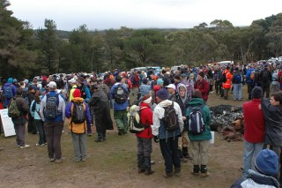

On a cold and wet Sunday Morning Ian and Tony disappeared early to check the river. The news was not good. Where there was usually only one ankle deep channel there were now three fast flowing waist deep torrents. The decision to chop the course was an unfortunate but easy one. The admin team of Bindi, our 7 year old son Stevie, Fiona, Geoff, Graeme and Andrew did an excellent job of getting through the load with crowd control help from Julian Ledger! My Mum and Dad coped with the early maps queue rush without any stresses. Andy and Kel spread the love around with the cars so no one would get stuck in the mud. All was going to plan, even the loo queues were not too bad.

The novices briefing reminded me why I hate public speaking and the final briefing confirmed it. Ian felt suitably empowered when he got to give a bunch of novices instructions in navigating.

After final instructions on how to use the electronic NAVLIGHT scoring system, 677 people in 255 teams headed north. For the organising team it was time too relax for a while and enjoy the sun that had finally made an appearance.

As predicted the top teams cleaned up the course in record time. The rest of the teams seemed to have a good time judging by the smiles on everyone’s faces.

A few random calls at the end had me scratching my head. There was a wallaby stuck in the fence to the north (thanks Tony for sorting out Wires). A few teams called to say they were running very late (it was good to know). Another team called to say they were south west of the hash house and running late… didn’t they mean south east or north east… no definitely south west… hmmm… Thankfully all the teams arrived back.

Thanks to the help of all the volunteers and the hugely successful NAVLIGHT system (well done Graeme) the results were posted within half an hour of the event finishing and presentations were finished by 4pm allowing everyone to get home.

On Tuesday I heard a news item about a group getting stuck not being able to cross a flooded Coxs… phew

The retrieval of the flags promised to also be a saga with the third wet week in a row delaying the retrieval of the remote flags in the course … those that weren’t used anyway (sob…from Ian). A few of the navlights were eaten by a mysterious creature… as Ian observed – Spooky. And Cruel.

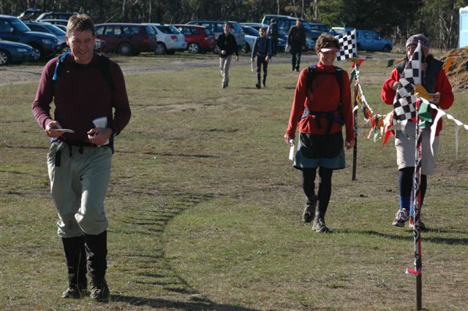

Have you noticed that 'rogaines' is an anagram of organise (thanks for this observation Ian). With this thought I would like to thank all the volunteers that helped us run this event.
- Ian for sorting out the course, the permissions, the hash house, all other general dogs body activities and making our life much easier
- Tony, Geoff and Julian for all the help with the course and all the help on the day
- Andrew I as the safety officer and photographer
- Graeme for coming down and sorting out all the Navlight stuff
- Other admin helpers Fiona and Stevie
- My Mum and Dad (Tony and Barbara) for turning up to their first Rogaine to help out
- Andy and Kel for sorting out the parking, lucky dip etc and all sorts of other things
- My 1st Waitara Scouts for providing sustenance before during and after the event.
- My darling wife Belinda for looking after all the admin stuff
Volunteers for upcoming NSWRA Rogaines - To add your name to the list below, please contact the Volunteer Co-ordinator, Graeme Cooper, Ph: 6772 3584 or email graeme_cooper@northnet.com.au

Paddy Pallin 6 hour  17 June 2007 | Lake Macquarie 12 / 6 hour  18 August 2007 | NSW Championships  20-21 Oct 2007 | Socialgaine 6 hour  18 November 2007 | Metrogaine 6 hour  24 February 2008
Organiser | Organiser | Organiser | Organiser | Organiser
Andrew Pope | Bert van Netten | Ian Dempsey | Greig Scott
Administrator | Administrator | Administrator | Administrator | Administrator
Belinda Pope | Bob Gilbert | Janette Dempsey | Peter McConaghy
Admin Assistants | Admin Assistants | Admin Assistants | Admin Assistants | Admin Assistants
Graeme Cooper | Graeme Cooper | Michael Watts, G Cooper
Course Setters | Course Setters | Course Setters | Course Setters | Course Setters
Ian Brown | Bert van Netten | B van Netten, Ian Dempsey | Greig Scott
Vetters | Vetters | Vetters | Vetters | Vetters
 |  | Robert Vincent, Will de Sain | Mick Driscoll
Flag Retrieval | Flag Retrieval | Flag Retrieval | Flag Retrieval | Flag Retrieval
 |  | David Dash, John Anderson
Caterer | Caterer | Caterer | Caterer | Caterer
1st Waitara Scouts | Junior Orienteering Squad
Hash House Team | Hash House Team | Hash House Team | Hash House Team | Hash House Team
not required | Jim Hubbard
Site Staff | Site Staff | Site Staff | Site Staff | Site Staff
 | Lou & Nick Vaccari
Photographer | Photographer | Photographer | Photographer | Photographer
Stuart Wilson | Stuart Wilson
Safety Officer | Safety Officer | Safety Officer | Safety Officer | Safety Officer
Results of 2007 Paddy Pallin held on 17/06/2007

Team | Team Members | Score | Time | O | M | W | X | V | S | J | N | F
72 | Stu Adams, Robert Vincent | 1050 | 4:10 | 1 | 1
143 | Nikolay Nikolaev, Philip Whitten | 1050 | 4:25 | 2 | 2
107 | Rob Preston, Paula Shingler | 1050 | 4:29 | 3 |  |  | 1
122 | Martin Lefmann, Pat Mickan | 1050 | 4:38 | 4 | 3 |  |  |  |  |  | 1
125 | Darlene Cheney, Mark Freeman, James Hayward | 1050 | 4:43 | 5 |  |  | 2 | 1
192 | Seb Dunne, Mace Neve | 1050 | 4:58 | 6 |  |  | 3
71 | Joel Mackay, Jonathan Worswick | 1050 | 5:14 | 7 | 4
52 | Martin Krause, Brad Simmons | 1050 | 5:16 | 8 | 5 |  |  | 2
157 | Jeremy Welbourne, Tony Welbourne | 1050 | 5:16 | 9 | 6
69 | Mick Driscoll, Greigor Scott, Jenny Scott | 1050 | 5:24 | 10 |  |  | 4
109 | Alexa McAuley, Wendy Stevenson | 1050 | 5:38 | 11 |  | 1
37 | John Barnes, Mardi Barnes | 1050 | 5:41 | 12 |  |  | 5
43 | Chris Waring, Miles Waring | 1050 | 5:41 | 13 | 7 |  |  |  |  |  |  | 1
92 | Ian Cameron, David Lyle | 1050 | 5:49 | 14 | 8 |  |  | 3
127 | Andrew Haigh, Nicole Haigh | 1050 | 5:56 | 15 |  |  | 6
170 | Geff Harper, Joel Wright | 1030 | 6:02 | 16 | 9
255 | Thomas Griffith, Shane Morgan | 1010 | 5:57 | 17 | 10 |  |  |  |  | 1
236 | Roland Cziferszky, David Williams | 980 | 5:36 | 18 | 11
201 | Mathew Everson, Anthony Kelshaw, James Mathews | 980 | 6:01 | 19 | 12
86 | Darren Smith, Eric Smith | 970 | 5:55 | 20 | 13
262 | David Kricker, Anna Kricker | 960 | 5:51 | 21 |  |  | 7
66 | Nick Dent, Colin Price | 950 | 5:55 | 22 | 14 |  |  | 4
131 | Joanna Sinclair, Duncan Sinclair | 950 | 6:01 | 23 |  |  | 8
204 | Paul Barton, Kate Carmody, Chris Snell, Margaret St Hill | 950 | 6:03 | 24 |  |  | 9
96 | Nils Bown, Nick Earl, Rob Mason | 930 | 6:10 | 25 | 15
73 | Ian Dempsey, Steve Guy, Wendy Scott | 920 | 5:49 | 26 |  |  | 10 | 5
68 | Alex Chew, Scott Mills | 910 | 5:55 | 27 | 16
278 | Ian Goodman, Steve Martin, Creel Price | 910 | 5:59 | 28 | 17
164 | Kelvin Proctor, Olivier Vallee | 900 | 5:58 | 29 | 18
199 | Gill Fowler, Megan Gamble | 900 | 6:05 | 30 |  | 2
206 | Rayward Anna, Damian Welbourne | 890 | 5:33 | 31 |  |  | 11
Team | Team Members | Score | Time | O | M | W | X | V | S | J | N | F
59 | Phil Harding, Carolyn Haupt | 890 | 5:34 | 32 |  |  | 12
67 | Richard Berling, Ron Junghans | 880 | 5:52 | 33 | 19 |  |  | 6 | 1
193 | Bruce Cook, Wil de Sain | 880 | 5:57 | 34 | 20 |  |  | 7 | 2
48 | Ann-Maree Carruthers, Paul Carruthers, David Longman | 880 | 5:58 | 35 |  |  | 13
227 | Alex Head, Ann-Marie Mulligan | 870 | 5:52 | 36 |  |  | 14
155 | Richard Lauder, Karl Spackman | 870 | 5:56 | 37 | 21
128 | Malcolm Bradley, Jo Payne | 870 | 6:03 | 38 |  |  | 15
40 | Sue Clarke, Chippy le Carpentier | 860 | 5:50 | 39 |  |  | 16 | 8
285 | Andrew Collins, Melissa Head, Anthony Knittel | 860 | 6:00 | 40 |  |  | 17
271 | Matous Bursik, David Lockwood, Michael Weilke | 850 | 5:49 | 41 | 22
238 | Emily Prudhoe, Paul Prudhoe | 850 | 5:51 | 42 |  |  | 18
97 | Glenn Schwarzel, Mark Schwarzel | 850 | 5:55 | 43 | 23 |  |  | 9
135 | Matt de Belin, Myf Lawrance | 850 | 5:59 | 44 |  |  | 19
163 | Tony Campbell, Stefan Kontermann, Trev Savage | 840 | 5:41 | 45 | 24
136 | Clement Armstrong, Adrian Clark, Robert Clark, Monique de Jong, Adrian Lee | 840 | 5:48 | 46 |  |  | 20
3 | Amy Von Huben, Mark Von Huben | 840 | 5:53 | 47 |  |  | 21
175 | Sam Buchanan, Lisa Perrett | 830 | 5:57 | 48 |  |  | 22
98 | James Bevan, Jo Boyd, Jacqui Knox | 830 | 6:04 | 49 |  |  | 23
64 | Robyn Pallas, Hilary Wood | 820 | 5:54 | 50 |  | 3 |  | 10
85 | Anne McGuire, Buzz Powell | 810 | 5:43 | 51 |  | 4 |  | 11
65 | Sieger De Vries, Jason King, Maarinke Van der Meulen, Campbell Wills, Andrew Wis | 810 | 5:49 | 52 |  |  | 24
186 | Rebecca Rees, Dean Wayne | 810 | 5:53 | 53 |  |  | 25
29 | Louise Dearnley, Martin Dearnley | 800 | 5:53 | 54 |  |  | 26 |  |  |  |  | 2
282 | Zoltan Klinger, Peter Wilson | 800 | 5:53 | 55 | 25 |  |  |  |  |  | 2
152 | Shelley Bambrook, Stewart Johnston | 800 | 5:59 | 56 |  |  | 27
232 | Ron Avery, Kevin Filan, Michael McGee, Richard Pinnock | 790 | 5:56 | 57 | 26
124 | Peter Hanselmann, Graeme Woodward | 790 | 5:57 | 58 | 27
144 | Gareth Chandler, Michael Were | 770 | 5:42 | 59 | 28
218 | Dan Ogden, Mal Roberts | 770 | 5:55 | 60 | 29
189 | Timothy Roy Booth, Nicolas Le Baut | 760 | 5:41 | 61 | 30
11 | Rhys Clarkson, Matthew Freeman, Nathan Gauci | 760 | 5:50 | 62 | 31
Team | Team Members | Score | Time | O | M | W | X | V | S | J | N | F
51 | Janine Friedrich, Aaron Simmons | 760 | 5:51 | 63 |  |  | 28 |  |  |  | 3
5 | Alicson Anderson, Shane Anderson, Stuart Brown | 750 | 5:39 | 64 |  |  | 29 | 12
15 | Lynn Dabbs, Kevin Williams | 750 | 5:47 | 65 |  |  | 30 | 13
105 | Julia Dixon, Bob Kenderes | 740 | 5:40 | 66 |  |  | 31
62 | Mark Hemmons, James Stuart, Keith Jebb, Bob Tucker | 740 | 5:52 | 67 | 32
53 | Eva Thompson, Stephen Thompson | 740 | 5:59 | 68 |  |  | 32
115 | Julie Avakian, Michael Avakian, Meg Croft, Lindsay Mackay | 740 | 6:00 | 69 |  |  | 33
151 | Dave Bere, Scott Hamilton | 720 | 5:24 | 70 | 33
80 | John Clancy, Chris Stevenson | 720 | 5:44 | 71 | 34 |  |  | 14
233 | Colleen Mock, Colin Mock | 720 | 5:46 | 72 |  |  | 34 | 15 | 3
287 | Debbie Cook, Robbie MacKillop | 720 | 5:49 | 73 |  |  | 35 | 16
23 | John Anderson, Peter Tamsett | 720 | 5:59 | 74 | 35 |  |  | 17 | 4
224 | James Dudley, Annie Heaton | 710 | 6:00 | 75 |  |  | 36 |  |  | 2
10 | Carol Jacobson, Ken Jacobson | 700 | 5:43 | 76 |  |  | 37 | 18 | 5
242 | Amanda Seymour, Jeremy Seymour, Martin Seymour | 700 | 5:49 | 77 |  |  | 38
230 | Duncan Cross, LeAnne Hanson | 700 | 5:52 | 78 |  |  | 39 | 19
31 | Karin Hefftner, Larry Weiss | 700 | 5:57 | 79 |  |  | 40 | 20
212 | Sam Clayman, Elsa Glanville, Katherine Tuft, Isaac Tyson | 700 | 5:57 | 80 |  |  | 41
219 | John Cullity, Willie Moulden, Peter Overton | 700 | 5:58 | 81 | 36 |  |  | 21
147 | Debbie Byers, Andrew Lumsden | 700 | 6:06 | 82 |  |  | 42 | 22
237 | Matt Ryan, Kate Wingrove | 680 | 5:37 | 83 |  |  | 43
182 | Thomas Schipilliti, Stephen Scott, Andrew Stanford, Adrian Watson | 680 | 5:41 | 84 | 37
263 | Brad Deane, Scott White | 680 | 5:47 | 85 | 38
268 | Andrew McGregor, Vaughan Shanks | 680 | 5:55 | 86 | 39
216 | Tim Coghlan, John Dickens | 680 | 6:06 | 87 | 40
14 | Nihal Danis, Richard Sage | 670 | 5:31 | 88 |  |  | 44 | 23
222 | Susan Kurrle, Robyn Tuft | 670 | 5:52 | 89 |  | 5 |  | 24
6 | Anne Newman, Lynne Trappel | 670 | 5:58 | 90 |  | 6 |  | 25
234 | Arwen Cross, James McElvenny, Jarrah Turton, Kulan Turton | 660 | 5:33 | 91 |  |  | 45
Team | Team Members | Score | Time | O | M | W | X | V | S | J | N | F
188 | Christopher Allen, Robert Allen | 660 | 6:18 | 92 | 41
33 | Julie Stanley, Paul Stanley | 650 | 5:27 | 93 |  |  | 46
89 | Brett Golledge, Tony Hayes, Louise Hayes | 650 | 6:01 | 94 |  |  | 47 | 26
211 | John Brayan, Paul Ettema | 640 | 5:42 | 95 | 42 |  |  | 27
246 | Rod Burton, Mark Young, Elanor Young | 630 | 5:36 | 96 |  |  | 48 |  |  |  | 4
162 | Kristi Bryant, Paul Bryant | 630 | 5:37 | 97 |  |  | 49
154 | Jarad Grice, Andrew Margetson, Alison Wolf, Richard Wolf | 630 | 5:49 | 98 |  |  | 50
250 | Sandra Thomas, Anne Turner | 630 | 5:51 | 99 |  | 7
168 | Michael Minehan, James Phimister | 630 | 5:59 | 100 | 43 |  |  | 28 | 6
88 | Luke Miller, Ryan Thomas | 620 | 5:29 | 101 | 44 |  |  |  |  |  | 5
114 | James McQuillan, Silvia Weiser | 620 | 5:31 | 102 |  |  | 51
79 | Ray Overdijk, Oliver Sieur | 620 | 5:54 | 103 | 45
38 | Barbara Barnes, Richard Barnes | 610 | 5:39 | 104 |  |  | 52 | 29
27 | Neil Beer, Peter Figiel, Danny O'Connell | 610 | 5:43 | 105 | 46
104 | Graham Chaffey, Tom Chaffey | 610 | 5:44 | 106 | 47
184 | Mark Coppock, Adam Hart, David Hart, Steve Jones, Paul Michels | 610 | 5:58 | 107 | 48
277 | Matt Lancaster, James Roche, Jamie Stewart | 610 | 6:03 | 108 | 49 |  |  |  |  |  | 6
103 | Karen Coughlin-Hall, Peter Holz, Dom Isberg | 600 | 5:39 | 109 |  |  | 53
197 | Debbie Hotchkis, Mike Hotchkis | 600 | 5:52 | 110 |  |  | 54 | 30
112 | Jo - Anne Pallister, Erika van Lennep | 600 | 5:53 | 111 |  | 8 |  | 31
49 | Nick Carter, Nick Glastonbury, Philip White | 590 | 5:07 | 112 | 50
254 | David Griffith, Emma Griffith, Renate Griffith, Robert Watson | 580 | 5:35 | 113 |  |  | 55
281 | Michael Kerr, Matthew Stacy, Jessica Strain, Adam Watson, Rachel Watson | 580 | 5:45 | 114 |  |  | 56 |  |  |  | 7
30 | Bill Chalmers, Carolyn Chalmers | 580 | 5:45 | 115 |  |  | 57 | 32 | 7
129 | Elisa Idris, Philip Von Huben | 580 | 5:57 | 116 |  |  | 58
181 | Jeff Bendeich, Conny Warn | 580 | 5:58 | 117 |  |  | 59
26 | Neil Chappell, David Lilley | 580 | 6:19 | 118 | 51 |  |  | 33 | 8
102 | Rebecca Anderson, James Laurie | 570 | 5:33 | 119 |  |  | 60
267 | Bel Crane, Tim Failes | 570 | 5:57 | 120 |  |  | 61
180 | Steve Gardner, Eva Hejnova | 570 | 5:59 | 121 |  |  | 62
171 | Phil Allen, Bob Bartle, John Guilly | 570 | 6:04 | 122 | 52 |  |  | 34 | 9
Team | Team Members | Score | Time | O | M | W | X | V | S | J | N | F
8 | Nikita Roberts, Malcolm Roberts | 560 | 5:03 | 123 |  |  | 63 |  |  |  |  | 3
253 | Sam Hill, Kirrilee Russell | 560 | 5:22 | 124 |  |  | 64
56 | David Craig, Paul Dyer, Bill Ford | 560 | 5:46 | 125 | 53
19 | Terry Murphy, Graeme Small | 560 | 5:47 | 126 | 54 |  |  | 35 | 10
251 | Katie Feeney, Graeme Malpass, Angela Malpass, Jamison Sharpley | 560 | 5:49 | 127 |  |  | 65
90 | Elizabeth Barnes, Geoffrey Barnes | 560 | 5:50 | 128 |  |  | 66 | 36
165 | Kirsten Dudley, Vonette Munro | 560 | 5:51 | 129 |  | 9 |  |  |  |  | 8
100 | Chris Mein, Tim Sheedy | 550 | 5:48 | 130 | 55
113 | Phil Foster, Mike Zikan | 550 | 5:56 | 131 | 56 |  |  | 37 | 11
256 | Megan Dimozantos, Jodie Sturgess | 550 | 5:57 | 132 |  | 10
194 | Carmel Wilkinson, Rebecca Wilkins | 550 | 5:58 | 133 |  | 11
24 | Melvyn Cox, Michaela Kupcakova | 540 | 5:05 | 134 |  |  | 67
225 | Kim Singleton, Jason Wilson | 540 | 5:16 | 135 | 57
101 | Peter Day, Phil Gibbs | 540 | 5:30 | 136 | 58
134 | Stephen Allport, Sarah Delaney, Catherine Taylor | 540 | 5:58 | 137 |  |  | 68
111 | David Gatwood, Simon Hunter | 540 | 5:58 | 138 | 59 |  |  | 38
1 | Ray Perry, Darren Shaw, James Short | 540 | 5:59 | 139 | 60
46 | Oliver Bock, Alan Roberts | 540 | 6:00 | 140 | 61
45 | Jacki Stitt, Vicki Stitt | 540 | 6:11 | 141 |  | 12
259 | Jan Hall, David Perkins, Michael Thompson | 530 | 5:52 | 142 |  |  | 69 | 39
207 | Robin Dearnley, Wade Rowston | 520 | 5:55 | 143 |  |  | 70 | 40
203 | Jenny Vaccari, Lou Vaccari, Nick Vaccari | 520 | 5:56 | 144 |  |  | 71
108 | Louise Glynn, Mike Robinson, Belinda Rothery | 510 | 5:34 | 145 |  |  | 72
280 | Abigail Gibson, Catherine Rollison, Phil Walsh, Caroline Wynn | 510 | 5:42 | 146 |  |  | 73
235 | Emma Botfield, Felicity Canham, Tom Meredith, Chris Sheil | 510 | 5:42 | 147 |  |  | 74 |  |  |  | 9
118 | Sue Bucknell, Melanie Freer | 510 | 5:49 | 148 |  | 13 |  |  |  |  | 10
78 | Timothy McConaghy, Peter McConaghy, Wendy McConaghy | 510 | 5:52 | 149 |  |  | 75 |  |  |  |  | 4
77 | Kathryn Carden, Andrew Mitchell | 510 | 5:54 | 150 |  |  | 76
81 | Graham Millar, Richard Smyth | 500 | 5:27 | 151 | 62 |  |  | 41 | 12
264 | William Kim, Thomas Lenzenhofer, Aunglatt Soe, Dana Xu | 490 | 5:41 | 152 |  |  | 77
Team | Team Members | Score | Time | O | M | W | X | V | S | J | N | F
150 | Michael Ferris, Andrew Pye | 490 | 5:50 | 153 | 63
139 | Liam Jewell, Jesse Luscombe, Philip Parsons | 490 | 5:55 | 154 | 64 |  |  |  |  | 3
21 | Tony Last, Ian Noffs | 490 | 5:55 | 155 | 65
270 | Brenden Brown, Bronwyn Powell | 490 | 5:57 | 156 |  |  | 78
75 | Alexander Massey, Chris Welbourne | 480 | 5:26 | 157 | 66 |  |  |  |  |  |  | 5
93 | Phillip Chan, Carolyn Chan, Peter Chan, Michiel Tops | 480 | 5:34 | 158 |  |  | 79
94 | Guy Eastwood, Robbie Eastwood, Rhys Ewing, Cliff Ewing | 480 | 5:40 | 159 | 67
209 | Ben Khan, Les Robinson | 480 | 5:52 | 160 | 68 |  |  |  |  |  | 11
195 | Michael Brungs, Nick Polin, Steve Martin, Greg O'Donnell | 480 | 5:55 | 161 | 69 |  |  | 42 |  |  | 12
61 | David Loong, James Loong, Anna Purvis-Smith | 460 | 5:39 | 162 |  |  | 80
179 | Lydia Chan, Karen Chung, Brian Turner | 460 | 5:55 | 163 |  |  | 81 |  |  |  | 13
173 | Melanie Johnston, Nerise McQuillan | 460 | 5:56 | 164 |  | 14
177 | Marcelle Schmelitschek, Cameron Schmelitschek | 460 | 5:57 | 165 |  |  | 82
137 | Chris Jewell, Rachel Jewell | 460 | 6:04 | 166 |  |  | 83
70 | Debbie Hancock, Kevin Hancock | 460 | 6:14 | 167 |  |  | 84 |  |  |  | 14
20 | Samuel Biddiscombe, Courtney Derriman, Lauren Jennens, Jesse Kay, Oliver Rowston | 450 | 5:26 | 168 |  |  | 85 |  |  | 4
22 | Rodger Austen, Rochelle Derriman | 450 | 5:27 | 169 |  |  | 86
221 | Glenn Jobbins, David Roberts, Mark Williams | 450 | 5:34 | 170 | 70 |  |  |  |  |  | 15
220 | Mark Ecob, Keith Sanchez, Shaun Scanlan | 450 | 5:34 | 171 | 71 |  |  |  |  |  | 16
60 | Sarah Glover, Karen Martin, Jackie Spurway, Lynn Stannus | 450 | 5:46 | 172 |  | 15
142 | Chris Johnson, Miles Johnson | 450 | 6:02 | 173 | 72 |  |  |  |  |  |  | 6
223 | Philippa Reynolds, Kevin Walton | 450 | 6:11 | 174 |  |  | 87
84 | Christopher Calwell, Jason Calwell, Christopher Mottram, Meagan Mottram | 440 | 5:04 | 175 |  |  | 88
160 | Richard Connors, Andrew Palmisano | 440 | 5:44 | 176 | 73 |  |  | 43
44 | Grace Waring, Julie Waring | 440 | 6:01 | 177 |  | 16
293 | Ann Dixon, Brad Harrower | 430 | 5:46 | 178 |  |  | 89 |  |  |  | 17
156 | Roslyn Richardson, Joanne Vanderstok, Geoff Warn | 430 | 5:51 | 179 |  |  | 90
274 | Poppy Danis, Paula Stuart | 420 | 5:14 | 180 |  | 17
Team | Team Members | Score | Time | O | M | W | X | V | S | J | N | F
41 | Talisen Brown-Robbins, Parrish Robbins | 420 | 5:31 | 181 | 74 |  |  |  |  |  |  | 7
258 | Alison Lyon, Len Sharp, Nicole Tyler, Rubina Usman | 420 | 5:52 | 182 |  |  | 91
213 | Grainne McGuire, Alexandra Middleton, Kellie Miller, Rebecca Wood | 420 | 5:59 | 183 |  | 18
153 | Jeff Ayres, Philippe Caron, Carl Mistler, Trent Oliver | 420 | 6:27 | 184 | 75
87 | Blake Macartney, David Morgan | 410 | 5:41 | 185 | 76 |  |  |  |  |  | 18
231 | Julie Gardner, Merinda Turton | 410 | 5:43 | 186 |  | 19 |  | 44
176 | Ian Almond, Jessica Almond, Bronwyn Wilson | 410 | 5:47 | 187 |  |  | 92
138 | Jordan Jones, Shannon Jones , Sam Perkins | 410 | 5:48 | 188 | 77 |  |  |  |  | 5
148 | Leisha Deguara, Tisha Dejmanee, Shane O'Malley, Celine Steinfeld, Chris Whelan | 410 | 5:58 | 189 |  |  | 93
292 | Travis Drape, Siobhan Fannin | 400 | 5:49 | 190 |  |  | 94 |  |  |  | 19
110 | Joy Burgess, Thais Turner | 400 | 6:12 | 191 |  | 20 |  | 45
202 | Keith Boicey, Kay Jacob, Ros Perry, Christine Wales, Ray Wales | 390 | 5:59 | 192 |  |  | 95
39 | Eric Barnes, Trish Beat | 380 | 5:34 | 193 |  |  | 96 | 46 | 13
146 | Louise Oliver, Clare Watts, Laura Watts, Michael Watts | 380 | 5:40 | 194 |  |  | 97
260 | Charles Bowden, Wenrong Huang, Jenny Kuo, Faye Xu | 380 | 6:00 | 195 |  |  | 98
169 | Tracy Bryan, Scott Cohen, Doreen Handy, Graeme Rollings | 370 | 5:46 | 196 |  |  | 99 | 47
289 | Amanda Jones, Lisa Marshall, Marie Mercer, Sara Wilson | 370 | 5:51 | 197 |  | 21
130 | Mina Bui, Garry Dobbie, Barbara Wroblewicz | 370 | 5:53 | 198 |  |  | 100
183 | Albert Chetcuti, Maud Mathie | 360 | 5:58 | 199 |  |  | 101 |  |  |  | 20
228 | Jim Hubbard, Bob McNairn, Greg Tuckwell | 360 | 5:58 | 200 | 78 |  |  | 48 | 14
4 | Andrew Heaton, Fatiah Issa, Eric Lawrenz | 360 | 6:22 | 201 |  |  | 102
226 | Kathryn Knight, Greg Knight, Olivia Knight, Sam Knight | 350 | 5:45 | 202 |  |  | 103
133 | Carolyn Hamilton, Kishore Sanghi | 350 | 6:00 | 203 |  |  | 104
240 | Melina Davidson, Julie Davidson, Tim Parkinson | 350 | 6:07 | 204 |  |  | 105
196 | Paul Kulmar, Robyn Kulmar, Anne Widmer | 340 | 6:19 | 205 |  |  | 106 | 49
Team | Team Members | Score | Time | O | M | W | X | V | S | J | N | F
261 | David Collins, Cathy Dowd, Annette Malicki | 330 | 5:43 | 206 |  |  | 107
247 | John Murby, Li Xue | 320 | 5:45 | 207 |  |  | 108 | 50
257 | Vivian Haslam, Katriona Herborn, Tim Herborn, Richard Salisbury | 320 | 5:46 | 208 |  |  | 109 | 51
244 | Deirdre Leslie, Reddall Leslie | 320 | 6:12 | 209 |  |  | 110 | 52
284 | Andrew Bain-Lindsay, Judith Greenwood, Shae Greenwood | 310 | 4:48 | 210 |  |  | 111
82 | Hannah Cole, John Cole, Sophie Cole | 310 | 5:23 | 211 |  |  | 112
55 | Michael Roylance, Richard Roylance | 310 | 5:48 | 212 | 79 |  |  |  |  |  |  | 8
141 | Catherine Perkins, Ross Perkins, Tom Perkins | 310 | 5:56 | 213 |  |  | 113
117 | Ellen Brackenreg, Kate Brackenreg, Mark Brackenreg, Rachael Brackenreg | 310 | 5:59 | 214 |  |  | 114 |  |  |  |  | 9
74 | John Hutchison, Victoria Hutchison, Geoff Montgomery, Laura Williams | 310 | 6:22 | 215 |  |  | 115
35 | Gail Siccardi, John Siccardi | 300 | 5:50 | 216 |  |  | 116 | 53 | 15
215 | Michael Valantine, Lois Valantine, Laura Valantine | 300 | 5:53 | 217 |  |  | 117 |  |  |  | 21
106 | Emily Ward, Stephen Ward, Tracy Ward | 300 | 5:54 | 218 |  |  | 118
123 | Karen Breckenridge, Stephen Breckenridge | 280 | 5:09 | 219 |  |  | 119 | 54 | 16
288 | Amanda Evans, Anita Fletcher, Elaine Mills, Diane Westaway | 280 | 5:50 | 220 |  | 22
249 | Robert Morgan, Sandra Parker | 270 | 5:45 | 221 |  |  | 120 | 55
200 | Ashley Vicary, Daniel Vicary, Michael Vicary | 270 | 6:05 | 222 | 80
12 | Allison Budnik, Debbie Bush, Heather West | 260 | 5:54 | 223 |  | 23 |  | 56
126 | Lisa Butt, Craig Dunn, Casey Dunn, Mitchell Dunn | 250 | 5:05 | 224 |  |  | 121
161 | David Gwillim, Sharon Gwillim, Siena Gwillim, Tayler Gwillim | 250 | 5:08 | 225 |  |  | 122
25 | Naomi Mayeux, Nicholas Mayeux, Sophie Mayeux, Jacques Mayeux, Charlotte Mayeux | 250 | 5:10 | 226 |  |  | 123 |  |  |  |  | 10
50 | Barbara Chapman, Kim Gibbs | 250 | 6:10 | 227 |  | 24 |  | 57
99 | Leigh Johnston, Christine Thoresen | 250 | 6:12 | 228 |  |  | 124 | 58
158 | Kathleen Beckenham, Coralie Hicks | 250 | 6:12 | 229 |  | 25 |  | 59
286 | Ben Tancred, Luke Tancred, Steve Tancred | 230 | 4:49 | 230 | 81 |  |  |  |  |  |  | 11
34 | Kaye Johnson, Peter Morrison, Patrick Webb | 230 | 5:12 | 231 |  |  | 125 | 60
283 | Annabel Harding, Glenn Harding, Jacob Harding, Lisa Harding, Kirsty Owen | 230 | 5:52 | 232 |  |  | 126
Team | Team Members | Score | Time | O | M | W | X | V | S | J | N | F
32 | Penny Allen, Marie Kibble | 220 | 5:44 | 233 |  | 26 |  | 61 | 17
13 | Laurie Bore, Margaret Bore | 220 | 5:54 | 234 |  |  | 127 | 62 | 18
18 | Rhett Henkel, Bruce O'Brien, Kelsey O'Brien | 220 | 6:00 | 235 |  |  | 128
7 | Patricia Forbes, Jason Von Ritten | 200 | 6:10 | 236 |  |  | 129
248 | Gary Barnard, Mark Collett, Sandra Kreckler, Helen Simpson | 190 | 6:19 | 237 |  |  | 130
210 | Jacqueline Fitzgerald, Thea Hutchings, Anthony Hutchings | 180 | 4:57 | 238 |  |  | 131
205 | Thomas Pisto, Kathie Pisto, Luke Pisto, Matthew Pisto, Robert Pisto | 180 | 6:03 | 239 |  |  | 132 |  |  |  |  | 12
121 | Janet Richards, Adrian Richards, Bethany Richards, Anna Richards | 170 | 5:15 | 240 |  |  | 133 |  |  |  | 22
266 | Bernadette Mackinnon, Caitlin Reynolds, Paul Reynolds, Brad Slater | 170 | 5:50 | 241 |  |  | 134
166 | Greg Hastings, Wyatt Leung, Huseyin Sumaktas, Alan Turner | 170 | 5:52 | 242 | 82 |  |  |  |  |  | 23
120 | Scott Campbell, Kylie Jackson | 160 | 4:40 | 243 |  |  | 135
190 | Vanessa Allen, Trish Densmore, Nick Smith | 160 | 5:51 | 244 |  |  | 136
76 | Kirsty Ward, Lisa Williams | 130 | 6:25 | 245 |  | 27
83 | Jenny Cole, Lily Cole | 70 | 1:43 | 246 |  | 28 |  |  |  |  | 24
91 | Alan Lowe, Lee Lowe | 70 | 5:09 | 247 |  |  | 137 | 63
132 | Jan Bouveng, Alison Bouveng, Stuart Bouveng | 50 | 6:28 | 248 |  |  | 138
159 | Heiko Schaefer, Mark Schaefer | 0 | 5:40 | 249 | 83
54 | Linda Hanna, Margaret McKenzie, Lisa Richardson | 0 | 6:26 | 250 |  | 29
140 | Gus Jones, Mitchell Jones, Sue Jones | Late
252 | Lina Eriksson, Jason Lee, John Saldin | Late
167 | Jay Parsons, Wayne Pepper, Rachele Williams, Kellie Wild | Late
245 | Mike Davies, James Goodwin, David Tweed | Late
276 | Erika Fonseca, Chris Meeny | Late

WHAT IS ROGAINING?

Rogaining is the sport of long distance cross country navigation, in which teams of two to five people visit as many checkpoints as they wish in a set time period. The traditional rogaine is 24 hours in duration, however, there are shorter events of 6, 8 and 12 hours. Most New South Wales events are held within two to three hours travelling time of Sydney. Most rogaines are on foot and held in attractive bush and farmland locations, however, some events are held in metropolitan areas (Metrogaines) or on bikes (Cyclegaines). Rogaining is a challenging adventure sport and is a lot of fun.

Who is it for?

Rogaining is a team activity for people of all ages and levels of fitness. Everyone from elite athletes to families with young children can enjoy rogaining. New rogainers are always welcome and assistance is always available from organisers to help get novices started.

The parts of the course you visit are entirely up to you and your team members. There are no set routes and you don’t have to spend the whole time on the course. You can return to the “Hash House” at any time for hot food and a rest around the campfire, or a sleep, before heading out again.

Some competitive teams may cover 50 kilometres in a 12 hour event and even more in an event of 24 hours duration. However, the distance you travel is entirely up to you. The satisfaction comes in finding your way around the course according to the route that you have chosen, and navigating back to the finish within the time limit.

What do you need?

Rogaining is good value for money. All you need is basic bushwalking gear including a compass, whistle, pencil, water bottle, comfortable and warm clothes and shoes, a waterproof jacket and a basic team first aid kit. On 12 and 24 hour events you may also wish to bring along camping gear and spend overnight at the Hash House.

What does it cost?

In New South Wales the entry fees vary from $30 to $70 depending on the event. This covers hot food during the event, your map, information sheets and facilities at the hash house. Family teams need only pay two adult entry fees.

CONTACT INFORMATION:

If you are interested in trying Rogaining then get in touch with one of those listed below or the contact specified for the next event.

NSWRA Public Officer – Julian Ledger: 9261 1111 (work) julianledger@optusnet.com.au
NSWRA Secretary – Alexa McAuley: 9460 3514 nswrasecretary@gmail.com

