Using NavLight

Scoring
This event will use NavLight electronic punching. NavLight has two main components, the punches and the tags. A tag is strapped to the wrist of each person in your team. A punch hangs from a cord at each control near the flag.
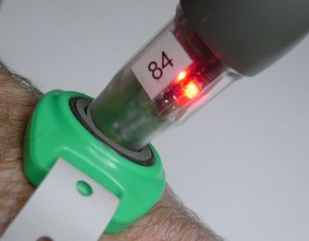
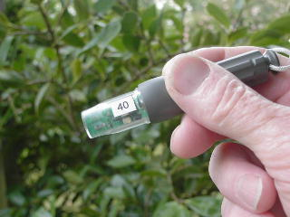

A Punch……. A punch and a tag……..

When you visit a control you record your visit by inserting the punch into the tag. You must hold the punch in the tag until the red light flashes to indicate that your visit was recorded.
A “Test” punch will be hanging beside a flag near Admin. You can use this to try your tag and see how the system works. It has no effect on your score.

Fitting the wristbands & testing.
The wristbands are made from a rugged vinyl material and cannot be removed from the wrist without breaking them. Wear them quite loosely. You should be able to fit two fingers comfortably between the band and your wrist. Over a long period, a tight strap will cause irritation. Thread the band through your Tag, wrap it around your wrist, then close the clasp through one of the holes in the strap. There is a loose end which you can pull off carefully.



