
www.nswrogaining.org
DRAFT
Minutes for the Annual General Meeting of the

NEW SOUTH WALES ROGAINING ASSOCIATION

Held on Sunday 22 February 2026
at Swansea High School, 78 Park Avenue, Caves Beach NSW 2281

Attendees: Graham Field, Robin Cameron, Mike Hotchkis, Arthur Day, Charles Kuan, Pam Montgomery, Bob Montgomery, Charles Kuan, Matt Berrington, Siobhan Tobin, Zoe Melling, Sharon Lambert, Peter Hopper, Julian Ledger, Ted Woodley, Martin Dearnley, John Anderson, John Havranek, Tim Porritt, Salomé Hussein, Stuart Warren, Chris Stevenson and John Clancy.

Apologies: Robin Cameron, Katherine Cameron, Michael Watts, Mark Von Huben
Meeting commenced at 2.20pm. Meeting Closed at 2.50pm.
- 1. Adoption of the minutes of the 2025 Annual General Meeting – Sunday 23 February 2025.
Motion put forward by Pam Montgomery. Seconded by Bob Montgomery. Carried
- 2. President’s Report to AGM Feb-2026, Graham Field
2025 Review

I’d like to thank members and the Committee for their support during my third year as President.
2025 has seen membership and event participation at a continuing high trend. We had 8 events (the same as 2024) and total event entries for the year was 2644 (up 164 on 2024). NSWRA Membership in 2025 was 1758 (an increase of 49 over the previous year).
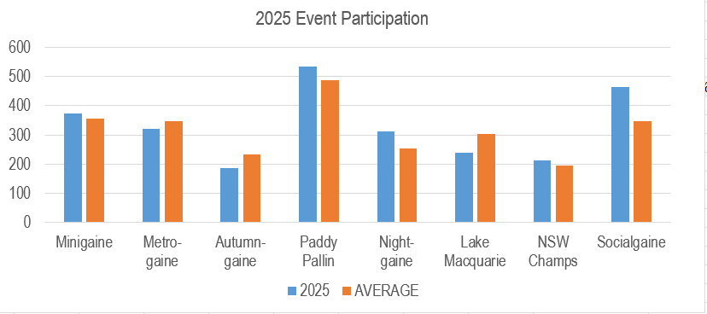

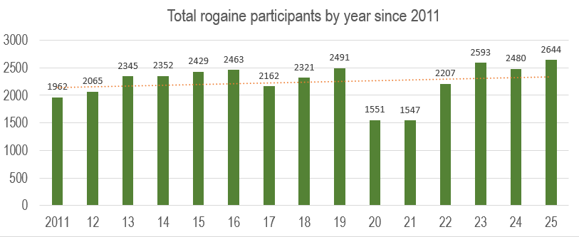

There was the usual even mix of bush and urban events and the Socialgaine at Engadine had a record attendance. The Paddy Pallin also had a strong, above average attendance. Demographically our average age is 41 years, and we split at approximately 43% female and 57% male.

Looking back

We had an ambitious calendar last year with a few events planned to stimulate interstate competition – the State of Origin challenge with Queensland at Coffs Harbour (the furthest event form Sydney in many years) was subject to torrential rain for the whole event and an unprecedented (for a couple of years) attack of leeches to add to the challenge. The climate, the environment and terrain added to the interstate challenge, for which NSW was victorious.

In contrast, the NSW Champs at Mt Werong was held in comparatively open country and perfect weather conditions. It attracted similar numbers for a comparatively distant bush event that was twice as long.

The cancellation of the Spring Challenge between NSW and ACT was disappointing. Making the decision to cancel the event due to a requirement for only on-track navigation was tough but correct to maintain a standard of contest for bush events. NSW will host the challenge in 2026.

Maintaining the balance between popular events close to Sydney and real bush events in increasingly regulated open bushland that attract fewer, but more seasoned and adventurous competitors is our ongoing goal and challenge.

The experience in December 2025 of giving evidence to the select NSW Parliamentary Committee into access restrictions to public lands – initiated by Julian Ledger’s submission on behalf of the NSWRA - highlighted the challenges that we will face in the future as the bushland that we rely on for rogaining in its purest form are further regulated and restricted.

Under the covers, the NSWRA Committee, aided by the hard-working sub-committees managing events and marketing has continued to work toward, and be guided by the goals of the strategic plan. Specifically:

- Scheduling and building well managed, safe events with an increasing degree of predictability and repeatable process.
- Ensuring communication to all members and potential members is regular, informative and interesting
- Getting more people to bring their experience, work and life skills to the association by being more than competitors.

Looking forward

We’re looking good for having a full set of events locked in for 2026 and I thank the course setters and coordinators for stepping up to get these in place. There will be seven events this year – one less than last year as we’re combining the Lake Macquarie and the NSW Championships to celebrate the 250th rogaine run by NSW Rogaining. This will be appropriately set by the legendary Bert van Netten in his native habitat, the Watagans.

We’re also planning a couple of very special events that will add some spice to the offerings this year:

- The Explorergaine (Metrogaine) at Mt Victoria - Coordinated by Julian Ledger and set by Steve, Sally and Bandit McKay. The event will celebrate the pioneers who crossed the mountains and will explore the first routes (known to Europeans) off the mountains, dating back to 1813. This will also be a fundraiser for the Australian Himalayan Foundation and will be honoured by the attendance of Greg Mortimer, from the first Australian team to climb Everest in 1984.
- The Ferrygaine (Socialgaine). Ted Woodley returns with an innovative twist on the Lane Cove series – this time with ferries and arguably the most scenic harbour island hash house location in the world at Cockatoo Island. This is looking to be a very popular (not to mention innovative) event that will showcase our unique harbour and surrounds.

Work is also well underway on the planning for the 2027 World Rogaining Championships in South Australia. Julian Ledger continues to work with the WRC Event Team coordinating the marketing efforts for the event. He’s being supported by Arthur Day who will be producing the 4 event bulletins and Bruce Sutton and Michael Watts who are looking after photography and video media. Julian adds that a lot of volunteers will be needed to run the event and we need to be thinking about how
and when NSW will participate, such as for a particular task like control collection. We’re hoping for a large contingent of NSW competitors and helpers for this event that comes too infrequently to our hemisphere.

Thanks to our volunteers across the board

Rogaining in NSW exists and goes forward through the time and effort that our volunteers give to the sport. In 2025 there were 140 volunteers across all of the events with a number of people volunteering for more than one event. This is 20 more than in 2024 and a reassuring statement that we have a healthy and engaged volunteer community.

I also make special mention of the people who work in the background to keep the wheels turning, but don’t always get thanked at events. In particular:

- Robin Cameron – our Volunteer Coordinator, Vice President and 2025 Warwick Marsden Awardee who ensures that all events have the right people in place and provides essential support for the Committee.
- John Clancy – the NSWRA Secretary who keeps the Admin of the Committee in order and who’s advice on governance and Committee matters I value immensely.
- Mike Hotchkis – who administers the Associations finances and works with event organisers to set and manage a budget for each event.
- Mark von Huben – who looks after all the equipment making sure that its operational for every event.
- Arthur Day – our newsletter editor who’s continues to set a very high standard in effective communication.
- Matt Berrington and Siobhan Tobin, our Web Admins working hard to modernise our website and keep it ticking over.
- Julian Ledger – who lends his considerable experience to the Association, manages the Marketing Group and is keeper of the trailers.
- Martin Dearnley – who coordinates the Events Group and provides support as a mentor across the board.
- Gill Fowler – who looks after our interactions with NPWS, Forestry and other land holders that allow us access to the land for rogaining.
- Chris Stevenson – our Membership secretary and past Web Administrator
- North Sydney Scouts and in particular Stuart Warren & Salomé Hussein.

I’d also like to acknowledge the service of our Event Admins Vivien de Remy de Courcelles and Anita Bickle and our dedicated Newcastle team including Bert van Netten, Anita Bickle, Carolyn Rigby and Pam and Bob Montgomery – they are always there to lend a hand.

2026 Committee
I expect that most 2025 Committee members will continue to be a part of the 2026 Committee. We also have 4 new members who have come forward to join the Committee this year, to be confirmed at the meeting.

I’ve decided that 2026 will be my last year as President (If elected of course), so we, the Committee, need to find a suitable person to fill this role. Ideally it should be someone who knows the ethos and mood of the sport as well as understand the workings and nuances of the Committee.
Thanks.. Graham.

- Treasurer’s report
The 2025 financial statements were presented at the AGM by the Treasurer.
A small profit of $3,538 was incurred at year end and some expenses relating to the 2026 Minigaine at Swansea were brought forward. It should be noted that NSWRA accounts are prepared on a cash basis.
With regard to our balance sheet, overall assets increased slightly to $69,625 following recognition of a small surplus recorded in our income statement. As per our constitution (rules) no income was distributed to members.
In summary, eight events took place in 2025. Eight events either broke even, or in the case of the metropolitan events continued to make a small surplus. Two events, Autumngaine held at Coffs Harbour on 26 April, made a loss $1,484 and the NSW Championships held a Mt Werong on the week end 13 and 14 September 2025 made a loss of $3,282
As in previous years, the aim of the Association is to maintain a float of $60k and thus have sufficient funding to support ongoing operations and events, as well as to have a reserve for emergency or unpredictable incidents. Total equity increased slightly to 69,625 represented by the association’s cash assets in the bank as at 31 Dec 2025.
Finally, our aim is to continue to run all events with entry fees balanced to the nature of the event and expected numbers. For instance, If we charge more for entry to the NSW Champs say, we risk deterring people from entering bush events. Our aim is to encourage more rogainer participation.
- Motion that the 2025 President’s Report, presented at 2026 AGM and the Accounts incorporating the 2025 Financial Statements as approved by the Committee and tabled at this meeting be adopted
Proposed by Matt Berrington; Seconded by Siobhan Tobin. CARRIED
- Election of Office Bearers for 2026
Committee Changes in 2025:
- Graham Field indicated that since there has been no nomination for the role, he is willing to continue as President. Robin Cameron will continue as Vice President.
- A Vote of thanks to Ted Woodley on behalf of the Committee for all his work over the last ten years. Supported by the Committee and attendees.
- A Vote of thanks to Martin Dearnley and the Members of the Event Sub-Committee for their contribution during 2025.
- A Vote of thanks to Julian Ledger and other members of the Marketing Sub-Committee for their contribution during 2025.

Committee 2026

- Welcome to Zoe Melling, Sharon Lambert, Peter Hopper & Ivan Koudashev

Position | Nominee | Proposer | Seconder
President | Graham Field | Julian Ledger | John Clancy
Vice-President | Robin Cameron | Julian Ledger | John Clancy
Treasurer | Mike Hotchkis | Julian Ledger | John Clancy
Secretary | John Clancy | Martin Dearnley | Graham Field
Public Officer | John Clancy | Graham Field | Julian Ledger
Publicity Officer | Arthur Day | Graham Field | Julian Ledger
Event Manager | Vacant ¹
Ordinary Members
Volunteer Coordinator | Robin Cameron | Ted Woodley | John Clancy
ARA Representative | Julian Ledger ² | Graham Field | John Clancy
Membership Secretary | Chris Stevenson ³ | Graham Field | John Clancy
Equipment Officer | Mark Von Huben | Graham Field | John Clancy
Safety Officer | Charles Kuan | Graham Field | John Clancy
Publicity Coordinator / Newsletter Editor | Arthur Day | Graham Field | John Clancy
WebAdmin(s) | Matt Berringotn & Siobhan Tobin | Graham Field | John Clancy
Archivist | Julian Ledger ² | Graham Field | John Clancy
General committee | Richard Sage | Mike Hotchkis | John Clancy
 | Pam Montgomery | Mike Hotchkis | John Clancy
 | Bob Montgomery | Mike Hotchkis | John Clancy
 | Zoe Melling
 | Ivan Koudashev
 | Sharon Lambert
 | Peter Hopper
Notes
- Event Management is now handled by the Events Subcommittee under the Chairmanship of Martin Dearnley.
- Julian Ledger is not a Committee member and holds these positions on request of the Committee.
- Chris Stevenson is not a Committee member and maintains the membership records and reports directly to the President and Public Officer.
- Web Administration duties have now been transitioned from Chris Stevenson to Matt Berrington and Siobhan Tobin.

- Other Business
- Review of the NSWRA Constitution. It is proposed the Constitution will be reviewed during 2026 including adoption of maximum terms for committee members and office bearers. All changes will be presented to the members for consideration and adoption.
- There was no other business, and Julian Ledger proposed a Vote of Thanks to Graham Field, all Members of the Committee and Volunteers who contributed to the success of NSWRA in 2025.

AGM closed: 2.50pm

